# **ETHYLENE PRODUCERS’ TECHNICAL SUBCOMMITTEE MEETING**

Date: Thursday, Feb 4, 2016

Time: 4:30 to 5:30 PM CDT

**MOM - DRAFT**

Location: Doubletree by Hilton Hotel Houston, TX

**Members:** Jack Buehler, Chell Chellappan, Alain Chepda, Bala Devakottai,

Greg Dunnells, Thomas Emmert, Anthony Hakim , Sanjeev Kapur, Robert Krinock, Aivars Krumins, Ravi Lal, Darren Le Geyt, Krishna Merchant , Alberto Morales, Mike Tallman, Greg Yeo, Tim Zygula

**Present:** …. Jack Buehler, Chell Chellappan, Alain Chepda, Bala Devakottai,

Thomas Emmert, Sanjeev Kapur, Robert Krinock, Ravi Lal, Mike Tallman, Tim Zygula

**Absent:** …. Anthony Hakim , Aivars Krumins, Greg Dunnells, Darren Le Geyt, Krishna Merchant , Alberto Morales, Greg Yeo

Distr: Above + [ethyleneproducerscommittee@gmail.com](mailto:ethyleneproducerscommittee@gmail.com)

***AGENDA***

1. Reading of the Anti-Trust Statement

No activity of the Committee shall involve the exchange, collection or dissemination among competitors of information, or be used for the purpose of bringing about or attempting to bring about any understanding or agreement, written or oral, formal or informal, express or implied, among competitors with regard to costs, prices or pricing methods, terms or conditions of sale, distribution, production quotas or other limitations, on either the timing, or volume of production, or sales, or allocation of territories or customers.

1. Five Minutes on Safety (5 mins)
2. Approval of Previous Meeting Minutes –Dec 10, 2015
3. Session Planning Status –

1. Feedback from Main EPC: (5 min)

2. Status of Fundamentals of Technology Session - Jack

3. Status of Feedstock Flexibility Session – Alain/Thomas

4 Status of “Innovations in managing capital costs of Ethylene based Petrochemical Investments – Sanjeev”

V. New business (5 min)

VI. Calendar for 2015 – 2016 - Upcoming Meeting Date Reminders:

* 2016 AIChE Spring Meeting / EPC Conference dates are 10-14 April 2016. Hilton Americas & George R. Brown Convention Center, Houston, TX

VII. Review Action Item List

VIII. Adjourn

Session Descriptions…

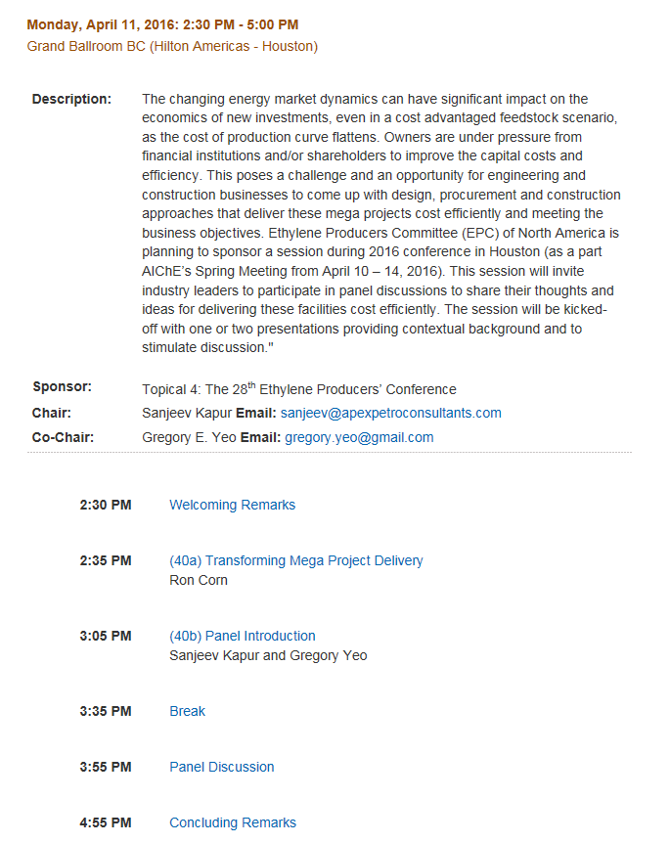

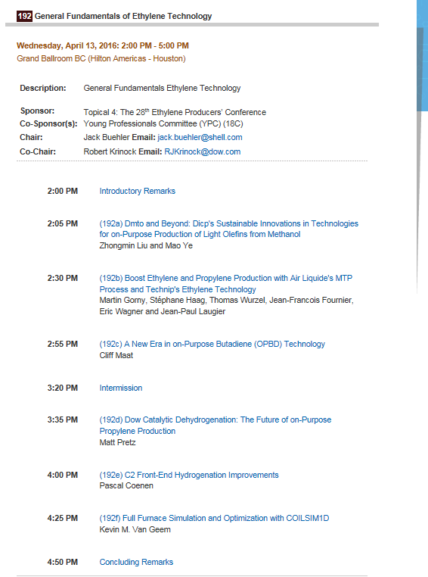

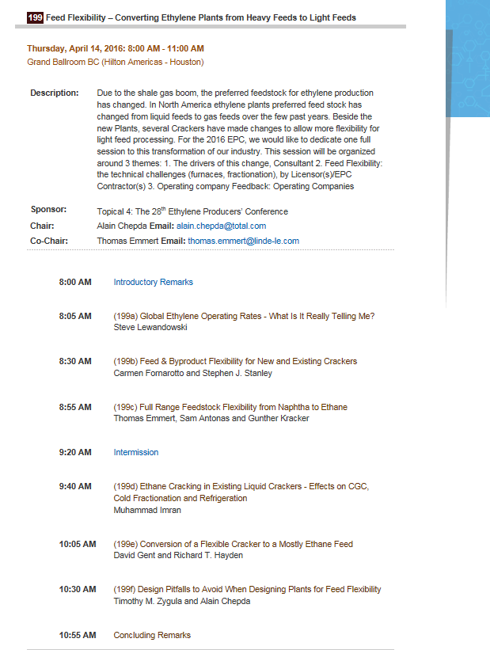

**Actual Feb4 Mtg.**

I. Reading of the Anti-Trust Statement

No activity of the Committee shall involve the exchange, collection or dissemination among competitors of information, or be used for the purpose of bringing about or attempting to bring about any understanding or agreement, written or oral, formal or informal, express or implied, among competitors with regard to costs, prices or pricing methods, terms or conditions of sale, distribution, production quotas or other limitations, on either the timing, or volume of production, or sales, or allocation of territories or customers.

II. Five Minutes on Safety (5 mins)

Bob K. reviewed the Feb 2016 “Process safety Beacon” newsletter that highlighted hydrocarbon storage tank fires. The CSB reported that 19 of the 22 major tank farm fires that have occurred since 1962, all involved a tank overflow events.

III. Approval of Previous Meeting Minutes

The Dec 10, 2015 meeting minutes were accepted & approved.

IV. Session Planning Status –

1. Feedback from Main EPC: (5 min)

**Important dates – Tim Z.**

* Session rooms are finalized

* **Papers Complete: March 18**

* **Slides Complete: March 29**

* Presentation authors need to accept the communication about recording their session.

* AIChE needs authorization to publish the papers/presentations

* There can be no “Business Confidential”, “Internal”, or other similar headers on the papers, or slides.

2. Status of Fundamentals of Technology Session – Jack

All papers look to be in good shape. Jack will send updates on any session speaker’s names to Tim Z.

3. Status of Feedstock Flexibility Session – Alain/Thomas

All papers are in good shape so far.

4 Status of “Innovations in managing capital costs of Ethylene based Petrochemical Investments – Sanjeev”

All panelists confirmed. Ron Conn will make a presentation only, with no paper.

V. New business (5 min)

The new Technical sub-committee members: Humera Rafique, and VK Arora will be invited to the 1st mtg for the 2016-2017 EPC planning cycle. Usually the 2nd week in June, on a Thursday. Greg Dunnells had agreed with his being removed from the Tech subcommittee, due to his long term work assignment in KSA.

Mike T. had asked about Allan Hatami’s subcommittee status….email discussions on Allan had occurred ahead of the Dec 10 mtg & one of the emails said to send his name to the Operations subcommittee, so he was not specifically discussed him at our Dec 10 mtg. The Operations subcommittee , has since invited Allan to join their group.

VI. Calendar for 2015 – 2016 - Upcoming Meeting Date Reminders:

* 2016 AIChE Spring Meeting / EPC Conference dates are 10-14 April 2016. Hilton Americas & George R. Brown Convention Center, Houston, TX

VII. Review Action Item List

VIII. **Feb 4 Adjourn**

Minutes prepared by RJ Krinock (Technology Subcommittee Chair) – Feb 15, 2016