**Glynn Dyer**

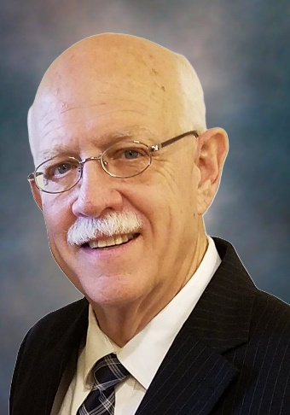

Glynn Dyer is a Fellow Technical Advisor with over 40 years’ experience at the Savannah River Site supporting nuclear fuel processing in F and H Canyons. He currently works for Omega Technical Services and subcontracts to Savannah River Nuclear Solutions. Glynn received a Bachelor’s and Master’s degree in Chemical Engineering from the University of Tennessee at Chattanooga. He started his career as a co-op student working for DuPont in Chattanooga and the Savannah River Plant. His co-op experience included working in two areas that are being turned into green space: the metal fabrication area (M-Area) and the semi-works area (TNX). After graduating with his Master’s degree, Glynn has spent his career supporting the F-Canyon and H-Canyon facilities at the Savannah River Site.

Glynn’s career covers multiple assignments and responsibilities in Engineering and Engineering Management. He has initiated and/or provided technical engineering support to three muti-million projects. He is a recognized Subject Matter Expert for hydrogen generation and radiolysis in process solutions, Accident Analysis support to Documented Safety Analyses, and technical support to H Canyon operations. Glynn has been identified as a Technology Guardian for mixer-settler modelling and operation. In support of electrolytic dissolution in H-Canyon, Glynn led the H-Canyon input on the Feasibility Study teams that recommended electrolytic dissolution for processing the Fast Critical Assembly fuel. His work looking back at the prior operation of the electrolytic dissolver in the 1970s was instrumental in the project to replace the dissolver with a spare to allow processing of stainless steel clad fuel.