2025 ChemE CubeTM Problem Statement

**Document Revision History**

|  |  |
| --- | --- |
| **Version (Date)** | **Comment** |
| 1.0 (January 2025) | Initial release of 2025 competition rules |

ChemE CubeTM Competition 2025

Problem Statement: Modular Direct Air Capture

# Business Objective

The carbon cycle is nature’s way of recycling carbon atoms from the atmosphere to the terrestrial organisms, ocean, land, and then back into the atmosphere. With the introduction of human carbon emissions, there has been a net positive increase of carbon dioxide in the air. Carbon dioxide emissions are the largest greenhouse gas (GHG) emissions globally, accounting for 76% of all GHG emissions annually[1] and reaching 34.8 billion tons in 2020.[2]

The rising CO2 emissions leads to increasing global temperatures, rise in ocean acidification, and disruption of ecosystems. The effects of climate change can directly and indirectly impact human health. In order to take into account this global issue, the 2015 Paris Climate Change Agreement was enacted in order to combat the rise of global CO2 emissions. Its goal is to limit global warming to preferably 1.5°C.[3]

There are different ways to reduce the amount of CO2 emitted. Conserving energy, efficient energy use, switching fuel type, and changes in use of land and land management practices help reduce the amount of CO2 emitted. Carbon capture and storage (CCS) can be used to capture CO2 at the point where it is emitted to keep it from entering the atmosphere. However, even after employing all of these approaches, many external technology assessments[4] suggest that additional steps will be needed to meet stated climate goals. This includes the deployment of direct air capture technologies, where CO2 in the air is removed and sequestered.[5] This is what your design will aim to achieve.

You are tasked with creating a modular direct-air capture mini-plant with both adsorption and regeneration that can fit inside a cube that is 1-foot in length, width, and height. Your mini plant must capture CO2 from surrounding atmospheric air. It is also important that your cube design is efficient so that the CO2 emissions that come from the energy (used to power the mini plant) is low. You will have a maximum budget of $1,500 for your first-of-a-kind prototype. Your design should be marketable as a modular CO2 capture device. Ultimately, it should create an impact by demonstrating technological breakthroughs, be able to address a market, and finally, benefit humanity.

## Related Efforts

The following related efforts may help to provide clarity and resources to you as you develop your cube:

* The United States’ National Energy Technology Laboratory Direct Air Capture (DAC) Center supports rapid development and commercialization pathways for technologies that remove CO2 from the atmosphere.[6]
* The Justice40 Initiative[7] was enacted by President Biden to ensure that 40% of the overall benefits of certain Federal investments go to communities that are underserved and overburdened by pollution. A cube such as this has the potential to address disproportionate needs of underserved communities.
* XPRIZE hosts a competition revolved around the removal of carbon dioxide.[8] They have noted three grand challenges that come with carbon dioxide removal: 1} Massive scale required for carbon dioxide removal, 2) Current DAC solutions are too expensive, and 3) Structural incentives are lacking from both the government and markets.
* The Direct Air Capture (DAC) Coalition supports the international effort to address the climate challenge by bringing together diverse, leading global innovators to educate, engage, and mobilize DAC technology.[9]
* Carbon Dioxide Removal Primer is a new online resource on the fundamentals of carbon dioxide removal and its role in addressing the climate crisis.[10]

# The Virtual Qualifying Presentation

Teams will first compete in a virtual qualifying presentation (VQP) to showcase their concept of their cube. The VQP should focus on the problem and your solution, why your solution is the best, the unique value proposition, preliminary calculations showcasing your design can capture CO2 effectively, and overview on safety. Refer to the VQP rubric for grading criteria. During this time, teams should not build an actual cube. The selected teams will move on to compete in the in-person competition.

We highly recommend using [***The Value Proposition Matrix: An Innovator's Guide to Four Questions That Separate Success from Failure***](https://www.amazon.com/Value-Proposition-Matrix-Innovators-Questions/dp/B09WQ4ZBN7)as a resource to develop your business plan and properly explain your value proposition. (This book will also be a good resource for The Pitch)

# The Ad

All teams will create a 1-minute project promotion video that will be due approximately two weeks prior to the onsite competition. This video should introduce your team, your approach, your solution, and the potential impact it will have. This is not the time to get into very specific technical information but to provide a high-level overview of your technical approach and highlight innovative elements or examples of creativity or resourcefulness.

Refer to the Competition Rules for information about required format and content. Refer to the Ad rubric for grading criteria.

# The Poster

A poster must be displayed with the ChemE Cube on the day of the competition. Most of your team’s technical description of your cube belongs on the Poster, including all references. Teams should use the poster template provided here. This poster should clearly describe:

1. Unique and innovative features of the cube
2. Cube design description, drawings, and testing results
3. PI and MCPI elements of the cube
4. A breakdown of the total capital equipment costs (including manufacturing costs)
5. The safety features/inherently safer design concepts applied to the cube
6. Reference material and data

Refer to the Competition Rules for information about required format and content. Refer to the Poster rubric for grading criteria.

# The Pitch

Teams will have twenty minutes to pitch their process to a panel of industry members. This pitch is expected to include elements that a start-up company formed to commercialize your cube technology would present to a group of angel investors, such as an IP and patent plan, understanding of the market, competitive advantage, financing required to bring the technology to market, and value proposition to the customer. Ten minutes will be allotted to the presentation and ten minutes for Q&A. See the rubric for exact criteria. *Important distinction: while you should highlight the unique and valuable aspects of your cube design, this is not a heavy technical presentation but a business pitch. The goal of The Pitch is to get someone to invest in your technology. You will act as if you are looking for seed funding as a newly formed startup and bringing a brand-new product to market.*

During the 10-minute pitch, teams will present the following, but are not limited to:

1. What’s The Context?
   1. Background of the Problem or Opportunity
   2. Proof of Market
2. What’s The Solution?
   1. Novel Design Overview
   2. Potential Impact for Market
   3. How the product will scale using PI and MCPI principles
3. How are you protecting your design?
   1. What is your IP plan?
   2. What portion of your design can you patent?
4. What are your financials?
   1. Capital Costs
   2. Operating Costs
   3. Profits
5. The Competition
   1. Competitive Landscape
   2. Key Differentiators
6. Why Should You Invest?
   1. Value Proposition
   2. Sustainability
   3. Intellectual Property Considerations

During the 10-minute Q&A, judges will pose questions about all aspects of the cube from the perspective of a potential investor – from design, to costs, to output. While it is anticipated that one team member may have specialized in one area over others, it is expected that each team member will be able to answer the judges’ questions. Refer to the Pitch rubric for grading criteria.

# The Run

**This year, the competition is moving away from the** **duel aspect and teams are now scored solely based off the performance of their own cubes.** The following below explains the different components of the run such as how the cube is set up during the competition, any requirements, and a breakdown of the scoring, including supplemental metrics that aren’t scored directly, but affect the final score. Each team will get two runs.

## Power

Cubes will be supplied with DC current only to allow for the use of off-grid power sources such as solar or wind power. Regulated 12 V DC power will be provided for the competition. Your plant must use exactly 12 V. For safety reasons, cubes may not exceed 10A or 120 watts. Cubes operating at a higher wattage will not pass safety inspection and therefore will not be able to compete. Power connections will be provided from standard male banana jacks (socket) color coded red and black to indicate polarity. Your cube must provide ***female*** banana plug socket interfaces to power your cube’s equipment. Ensure that your plugs are not “bulging” out and are uniform in size to ensure a proper connection with the power supply (See Figure 1 for reference). Cubes should provide suitably insulated, properly gauged leads not less than 12ft in length terminated in standard banana plugs to access the provided power. (See Figure 2 for reference). During the runs, total power consumption will be measured using an in-line power meter.

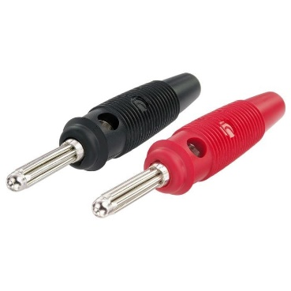

Figure 1: Male banana plugs from supplied power supply that must interface with your cube.

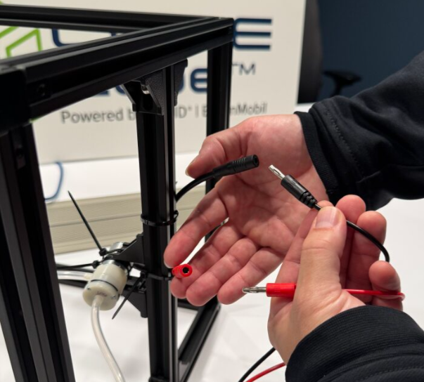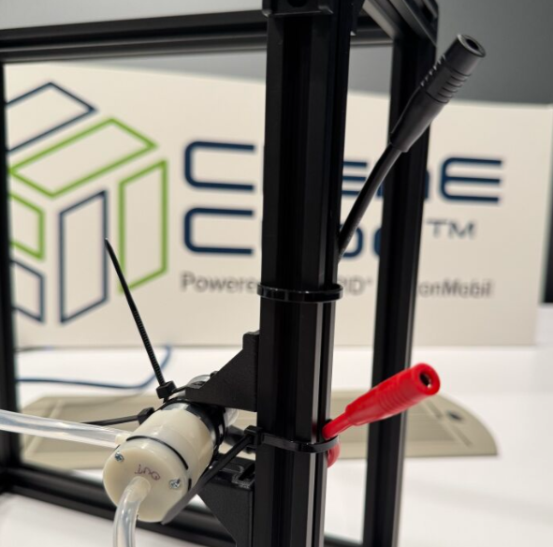

*Figure 2: Connection Points for Power for Cube - Notice the example cube is providing female banana jack connections.*

## Inlet

* At the inlet side, teams will need to pull air (via suction) from the air inlet ballast tank into their system. This is to prevent large fluctuations of CO2 concentrations during the run.
* Air will NOT be pumped into your system.
* A single CO2 meter will be connected directly to the ballast tank to record the concentration of CO2 at the inlet. Teams will be given that CO2 reading at the start of the run.
* A rotameter will be connected between the ballast tank and the cube to monitor the inlet flowrate. Teams are not required to install a flowmeter in their cube.
* The inlet flowrate must be between 0.3 SCFH and 20 SCFH (0.15 L/min – 9.4 L/min).
* Teams are advised to not have long tubing sticking out of their cubes. The setup during the competition will provide adequate length tubing from the ballast tank to connect to each team’s cube.
* Teams must use PVC tubing with **1⁄8** inch I.D. and ¼ inch O.D. to ensure proper connection with the supplied connection point (See Figure 3 for reference).
* Teams are recommended to label cube inlet connection to avoid accidental backflow line-ups.

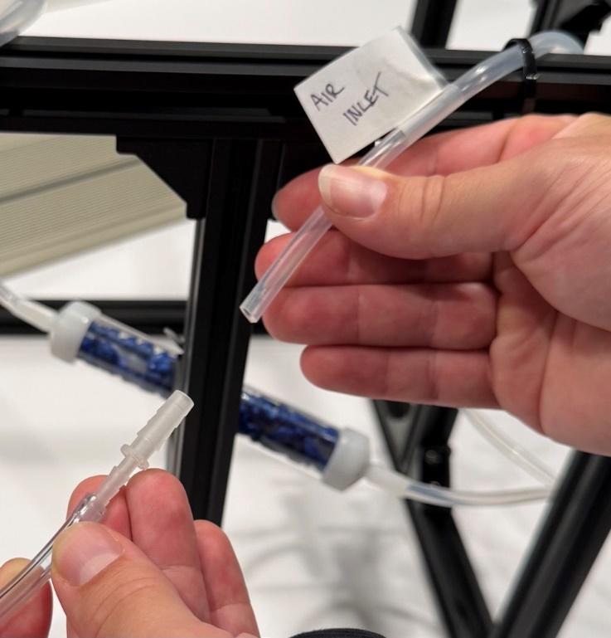

A

B

Figure 3: Connection Points for Cube Inlet. Point A is the connection source from the ballast tank and flowmeter that will be provided during the competition. Point B is the Cube Air Inlet. Air will flow in the direction shown by the blue arrow.

## Outlet

* The CO2 meter will run in parallel “sample loop” configuration, as seen in Figure 5, to avoid excess pressure drop of sending all product air through the meter.
* The flowrate will be monitored by a rotameter after the CO2 meter. There will be no required outlet flowrate. The maximum measurable outlet flowrate is 9.4 L/min.
* Teams are advised to not have long tubing sticking out of their cubes. The setup during the competition will provide adequate length tubing from the ballast tank to connect to each team’s cube.
* Teams must use PVC tubing with **1⁄8** inch I.D. and ¼ inch O.D. to ensure proper connection with the supplied connection point (See Figure 4 for reference).
* Teams are recommended to label cube outlet connection to avoid accidental backflow line-ups.

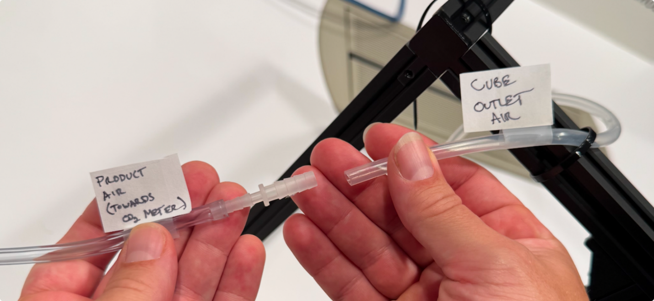

B

A

Figure 4: Connection Points for Cube Outlet. Point A is the Cube Air Outlet. Point B is the connection source to the CO2 meter and rotameter that will be provided during the competition. Air will flow in the direction shown by the blue arrow.

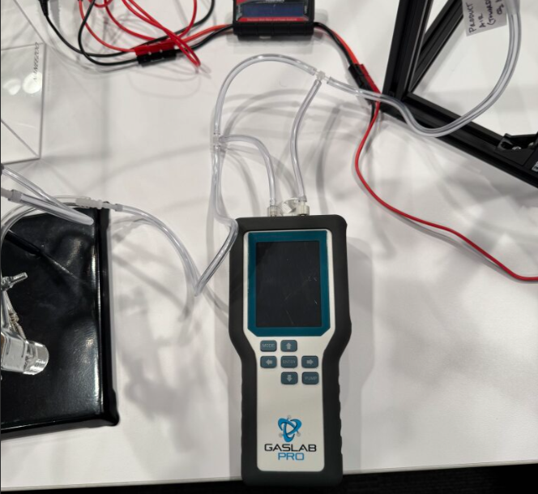

Figure 5: Parallel Setup of CO2 Meter at the Outlet. The meter will pull air from the outlet at a flowrate of 0.1 L/min and pump it back. The blue arrow represent the airflow from the cube to the rotameter. The orange line represents the air being pulled from the outlet line into the CO2 meter. The green line represents the air pumped out of the CO2 meter back to the outlet line.

## Regeneration Questionnaire

Due to the difficulties of incorporating a regeneration step in your cubes for the competition (safely in a conference center environment), we are introducing a unique approach this year. There will be a questionnaire that teams will use to evaluate their hypothetical regeneration process. Each regeneration method will have its own price and will be considered in the “Total Cost to Capture” criteria. The price of the regeneration will be calculated based on the energy/heat required to bring the specific adsorbent to its regeneration temperature, and to overcome the desorption/reaction energies necessary to evolve CO2. Regenerations for systems with stronger CO2 binding energies will be more energy intensive, and some proposed methods will have added complexity accounted for in the cost to regenerate. The amount of material subject to this regeneration calculation will be based on your total sorbent weights, regardless of actual CO2 loading in the run. As such, it behooves teams to minimize excess sorbent in your cube. Below are the possible categories you may choose for regeneration:

* Strong aqueous base
* Strong aqueous base with causticization step (cube must precipitate a calcite during the run to claim this regen benefit)
* Strong aqueous base with a Bi-Polar Membrane Electrodialysis system (cube must include a BPMED membrane use in the run to claim this regen benefit)
* Liquid amine (i.e. MEA)
* Amino Acid based capture system (i.e. PyBIG)
* Ion exchange resin with TSA
* Ion exchange resin with TVSA (applicants must provide supplemental assessment why TVSA is more economical or feasible than TSA)
* Supported MOF with TSA
* Supported MOF with TVSA (applicants must provide supplemental assessment why TVSA is more economical or feasible than TSA )
* Supported amine (i.e. PEI) with TSA
* Supported amine (i.e. PEI) with TVSA (applicants must provide supplemental assessment why TVSA is more economical or feasible than TSA)
* Algae/Bio base assuming some form of bio-sequestration (i.e. BECCS)
* Moisture Swing (i.e. ion exchange resin)

In addition to the score-contributing regeneration cost calculation based on the qualifying methodology, teams must provide calculations explaining the expected regeneration costs for their DAC systems. These calculations should use literature citations or commercial product specifications to define the sorbent specific regeneration temperatures, heat capacities, heats of reaction, sorbent loadings, type of energy inputs, energy prices, a description of the process flow required to perform the regeneration, and a calculation showing what you would expect your regeneration costs would be on a $/ton of sorbent, and $/ton CO2 basis.

The regeneration questionnaire can be found on the ChemE Cube website.

## Weight regulations

Your cube will be measured twice during the competition, in order to correctly measure the total amount of sorbent in your cube. The first weigh-in will take place during the safety inspection. Here, cubes will have no adsorbent loaded. The second weigh-in will take place during the run. Here, cubes will be loaded with adsorbent. Major physical modifications are not allowed in between the two weigh-ins. If a small modification is needed, your cube will be weighed again.

## CO2 Capture Wager

Runs will also include an aspect to allow teams to demonstrate their control of the DAC reactions in their cube systems. At the beginning of each run, teams will be told what the current CO2 concentration is within the Air Inlet Ballast Tank, and they will need to submit a wager on the total amount of CO2 their cube will capture during the run. Wagers will be made as standard volumes of CO2 in mL. Your total run score will be impacted based on how close your wager is to the actual amount of CO2 captured during the run.

## Pricing of Materials

This year, the competition will introduce standardized pricing of materials to ensure a more even playing field. Teams will be required to use the prices on McMaster-Carr their materials when calculating the capital cost of their cube. Chemicals can still be ordered as before.

For 3D printed and machined parts, there is an overhead charge of $200 not including material used. To price the material, teams will take the percentage of material used and multiply that percentage by the cost of the said material (use McMaster-Carr prices). For example, a spool of [black, good tensile strength, PLA filament](https://www.mcmaster.com/3502N211/) costs $47.27 and weighs 1000 grams. After printing, the final product (including the supports) weighs 600 grams, so 60% of the filament was used. Therefore, the price of filament that was used is $28.36. This price will be used in the capital cost.

Below is an example pricing chart that can be used as a template when showing capital cost on the EDP.

|  |  |  |  |
| --- | --- | --- | --- |
| Table 1: Example Table of Listing Out Materials to Calculate the Capital Cost of Cube | | | |
| Item | Price | Qty/Amt Used (kg) | Total Cost |
| [3-Way Outside Corner End Bracket, for 1" High Rail](https://www.mcmaster.com/47065T244/) | $12.14 | 8 | $97.12 |
| [Piping for System](https://www.mcmaster.com/5233K52/) | $12.00 | 1 | $12.00 |
| [Miniature Air Compressor](https://www.mcmaster.com/4404K25/) | $405 | 1 | $405 |
| 3D Print Charge | - | - | $200 |
| [PLA Filament (Used to build frame)](https://www.mcmaster.com/3502N211/) | $47.27 | 0.6 | $28.36 |
| [Wiring](https://www.mcmaster.com/9697t1/) | $4.50 | 1 | $4.50 |
| [Female Banana Plug Lead](https://www.mcmaster.com/6933K87/) | $8.34 | 2 | $16.68 |
| [Ethanolamine, 99%, 250mL](https://www.fishersci.com/shop/products/ethanolamine-99-thermo-scientific/AC149582500?gclid=EAIaIQobChMIwp7dpLSLiwMVCvGUCR0i8ju9EAAYAyAAEgLXjfD_BwE&ef_id=EAIaIQobChMIwp7dpLSLiwMVCvGUCR0i8ju9EAAYAyAAEgLXjfD_BwE:G:s&s_kwcid=AL!3652!3!712883467666!!!s!!&gad_source=5) | $43.01 | 1 | $43.01 |

## Returning Teams

Teams that participated in the 2023 and 2024 competitions are not allowed to reuse a previous design and must display an appreciable change. This can be shown as:

* Material size difference in the vessels containing the active material
* Difference process flow configurations
* Different sorbent

We encourage teams to explore different avenues and experiment with different capture methods, however the use of a different capture method is not required.

## Run Timing

Format: Each team will compete in two separate runs; each takes place over 20 minutes.

* The first 5 minutes will be setup/startup of the cube.​
  + Note that any CO2 capture capacity consumed during this setup period will NOT count towards your total CO2 captured, so make sure that your set-up/start-up procedure is appropriate to maintain the viability of your capture device during the run.
* The next 10 minutes, the cube will run autonomously.​
  + This will be the recorded period during which the run will be scored. Outlet air concentration, flow rate, temperatures, and cube power consumption will be measured and recorded continuously during this period.
* Final 5 minutes will be the shutdown and disconnection of the cube.

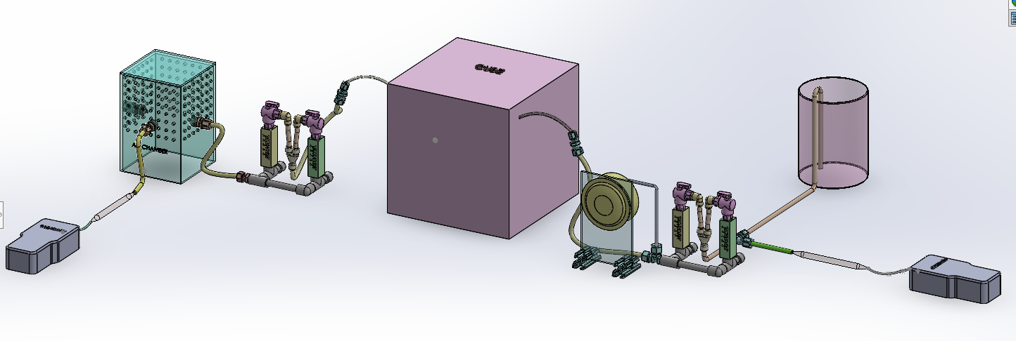

*Figure 6: 3D Render of the Setup during the Competition.*

### Run Scoring Criteria

|  |  |  |  |
| --- | --- | --- | --- |
| Table 2: ChemE Cube: Direct Air Capture Scoring Criteria | | | |
| Criteria | Scoring Type | Point Values | How the criteria are measured |
| CO2 Wager  Teams wager how much CO2 they think their cube can capture. The closer a team is to their wager, the higher the score multiplier is that will be applied to the four weighted CO2 capture criteria. No direct points are given to the team with the closest wager. | | | |
| Total CO2 Captured Weighted by Cube Cost (mL/$) | Weighted Score | 0-30 | Taking the average CO2 captured across 10 minutes, dividing it over the cost of the cube. |
| Total CO­2 Captured Weighted by Power Consumption (mL/Wh) | Weighted Score | 0-30 | Taking the average CO2 captured across 10 minutes, dividing it over the total power consumption. |
| Total CO2 Captured Weighted by Cube Mass (mL/kg) | Weighted Score | 0-30 | Taking the average CO2 captured across 10 minutes, dividing it over the weight of the cube (measured before the run). |
| Total Cost to Capture ($/g CO2) | Weighted Score | 0-120 | This criteria incorporates team’s power consumption, cost of materials, and the regeneration step chosen. |
| The following criteria are associated with the safety of operating your team’s cube. By applying for the competition, you are indicating that your team has fully reviewed and agrees to follow the ChemE Cube Safety Program, documents can be found on the ChemE Cube website. | | | |
| Temperature of Exhaust Stream | Absolute Score | 0 or 20 | Temperature must not exceed 95F due to safety considerations. |
| Smell | Absolute Score | 0 or 20 | Points are awarded if teams have a system that does not give out an unpleasant smell. |

# Scoring Breakdown

A total of 1000 points can be scored across the competition:

* Run: Maximum 600 points
  + Maximum 250 points per run
  + Bonus points ranging from 5-100 are awarded to the top 8 teams with the lowest total cost to capture
    - 1st Lowest: 100 Points
    - 2nd Lowest: 90 Points
    - 3rd Lowest: 75 Points
    - 4th Lowest: 60 Points
    - 5th Lowest: 45 Points
    - 6th Lowest: 30 Points
    - 7th Lowest: 15 Points
    - 8th Lowest: 5 Points
* Pitch: Maximum 200 Points
  + Maximum 100 Points for presentation
  + Bonus Points ranging from 0-100 points for amount of investment dollars received.
    - 1 Point per $1,000. Maximum $1,000,000 investment per team.
* Ad: Maximum 100 Points
* Poster: Maximum 100 Points

1. <https://www.epa.gov/ghgemissions/global-greenhouse-gas-emissions-data>
2. <https://ourworldindata.org/co2-emissions>
3. <https://unfccc.int/process-and-meetings/the-paris-agreement/the-paris-agreement>
4. https://www.iea.org/reports/net-zero-by-2050
5. [An updated roadmap to Net Zero Emissions by 2050 – World Energy Outlook 2022 – Analysis - IEA](https://www.iea.org/reports/world-energy-outlook-2022/an-updated-roadmap-to-net-zero-emissions-by-2050)
6. <https://netl.doe.gov/dac>
7. <https://www.whitehouse.gov/environmentaljustice/justice40/#:~:text=What%20is%20the%20Justice40%20Initiative,underserved%2C%20and%20overburdened%20by%20pollution>.
8. [$100M Prize For Carbon Removal | XPRIZE Foundation](https://www.xprize.org/prizes/carbonremoval)
9. [Direct Air Capture Coalition (daccoalition.org)](https://daccoalition.org/)
10. <https://cdrprimer.org/>