Virtual Chem-E-Car Competition Camera Guidelines

Note: Each team must set up competition track (no more than 5 meters wide and 33 meters long), prep area and camera angles in accordance to guidelines provided by AIChE Staff. This document will stipulate below the important checkpoints of the entire run that **must** be shown during this competition.

1. It is important to include the following checkpoints and modifications:
   1. Car at starting point
   2. Entire run of the car itself
   3. Car at stopping point and distance measurement
   4. Track will be marked at every 1-meter for a point of reference for the audience; once the distance is announced on the day of the competition, the finish line will be drawn as well. Finish line must be distinguishable from the 1-meter marks.
2. Teams will set up their track, markings, camera angles exactly as mentioned below:
   1. Camera 1 (Mobile): Each team has a dedicated team member who will initially show the track in its entirety before the start of the run; once run begins, the camera follows the car until its stops.
   2. Camera 2 (Stationary): Situated behind the starting line, Camera focused on the starting lines front and center looking down the entirely of the track; Camera Elevated enough to see the car in full.
   3. Teams will mark their tracks at every 1 meter mark with tape and label each tape exactly as shown in the document named “Track Figure”. You can also see the Image B on the next page.
3. At the beginning of each run, teams will use their mobile camera to show the car alignment with the starting line using a straight edge as shown on Image A. Once the judges are satisfied with the set up and camera angle, the 2 minute run time will begin:

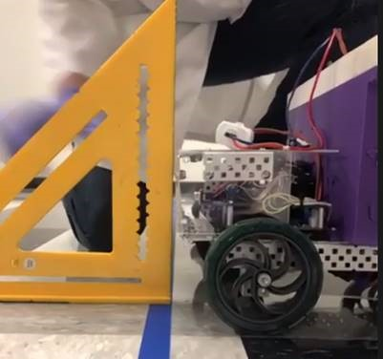

FigureA

1. Use the same straight edge as was used at the starting line to mark where the final stopping point of the car is located. Measurements will be taken to that location.

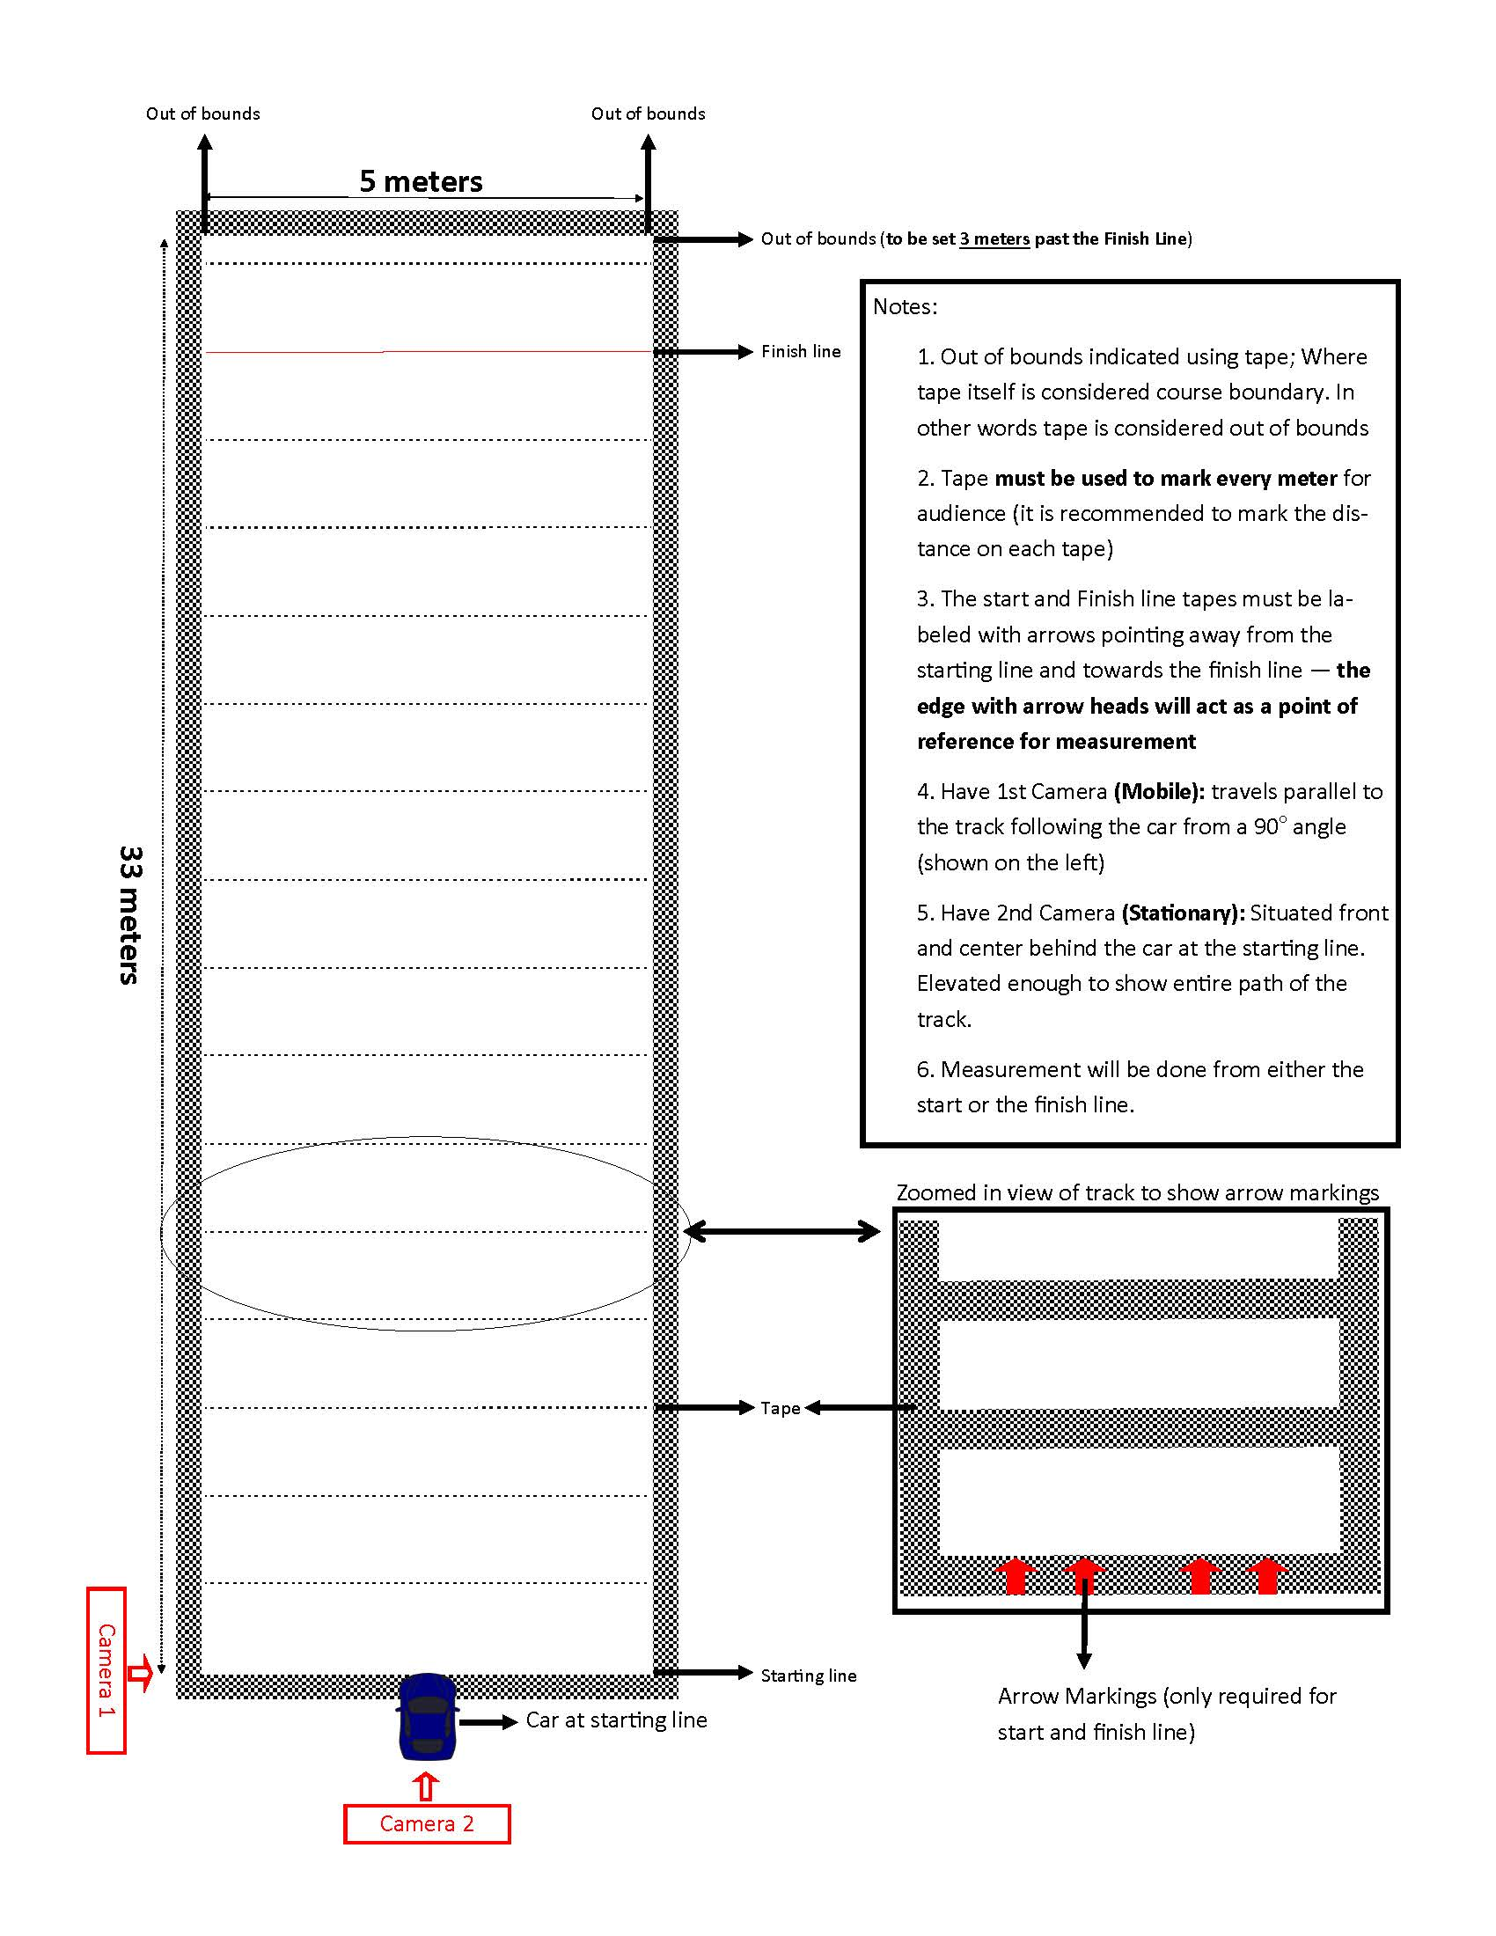

Figure B